Life Cycle Assessment of Staked Net Cage Aquaculture in the Coastal Area of Semarang, Indonesia

Nana Kariada Tri Martuti¹, Putri Alifa Kholil^{1*}, Fulia Aji Gustaman², Dhita Prasisca Mutiatari³

¹Department of Environmental Science, Faculty of Mathematics and Natural Sciences, Universitas Negeri Semarang, Semarang City, Indonesia 50229
²Department of Sociology and Anthropology Education, Faculty of Social Sciences and Political Science, Universitas Negeri Semarang, Semarang City, Indonesia 50229
³Yayasan Akar Banir Indonesia, Semarang City, Indonesia
*Corresponding author’s e-mail: putrialifa@mail.unnes.ac.id

ABSTRACT
Open-water aquaculture systems in tropical Asia are facing increasing scrutiny due to their dependence on fossil fuels and synthetic polymer infrastructure. However, life-cycle evidence from the Southeast Asian context remains scarce. Milkfish (Chanos chanos), one of the region’s most important finfish commodities, is commonly cultured in staked net cages, but no life cycle assessment (LCA) has evaluated this system, creating a geographical and system-level gap in the literature. This study provides the first attributional, gate-to-gate LCA of milkfish grown in staked net cages using extensive primary field data from Semarang aquaculture farms, complemented with background data from established LCA databases. Five production stages were modeled for a functional unit of 1 ton of live fish at the farm gate. Environmental impacts were characterized using the ReCiPe 2016 Midpoint (H) method for global warming, fine particulate matter formation, ozone formation (terrestrial ecosystems), terrestrial acidification, and fossil resource scarcity. Results show that the system is strongly driven by material and fuel-related burdens. Site preparation dominated all impact categories, contributing 63-82% of total impacts, primarily due to the use of nylon-6 nets and material-intensive infrastructure. Grow-out and harvesting were the next largest contributors, driven by gasoline combustion during daily patrols, feeding, and mobilization for harvest. Normalization identified fossil resource scarcity as the most influential impact, reflecting the system’s reliance on fossil-derived materials and fuels. These findings fill a significant regional data gap and highlight two actionable mitigation priorities: extending the lifetimes of nylon-6 nets and improving fuel efficiency in boat operations.
Keywords: Life Cycle Assessment, Milkfish, Staked Net Cage, Aquaculture, Coastal Area

INTRODUCTION
Aquaculture plays an increasingly essential role in global food security, surpassing capture fisheries in total production and expanding rapidly across coastal regions of Asia (FAO, 2024). This rapid expansion has raised concerns about the environmental performance of open-water aquaculture systems, particularly due to the use of fossil fuels and the material-intensive infrastructure that contribute to greenhouse gas emissions and the depletion of fossil resources (Rossi et al., 2024; Zoli et al., 2024). Life cycle assessment (LCA) has therefore become a crucial tool for quantifying environmental burdens and supporting sustainable planning in aquaculture (Ghamkhar et al., 2021).
Although LCA applications in aquaculture are growing, most studies focus on temperate, high-value species such as salmon, seabass, and shrimp, and are geographically concentrated in Europe, China, and the Americas (Bohnes et al., 2019). Only a limited number of LCA studies have examined tropical systems in Southeast Asia, such as tilapia farming in Malaysia and Thailand (Chairat et al., 2025; Dullah et al., 2020). These studies consistently highlight feed, fuel, and cage materials as key environmental hotspots; however, no study has assessed milkfish (Chanos chanos) grow-out in coastal net-cage systems, despite the species' significant importance in regional aquaculture (Alimorin, 2025; Tahiluddin et al., 2025). Existing milkfish research generally addresses ponds or fingerling production, leaving the environmental profile of coastal grow-out operations unquantified (Pianjing & Wites, 2021; Supartono et al., 2015).
A second major knowledge gap concerns the production system. While floating net cages and land-based ponds are well-represented in the LCA literature (Henriksson et al., 2012; Pagnotta, 2025). However, staked net cages, which rely on bamboo or wooden stakes and multilayer nylon nets, have not been evaluated. Structural and hydrodynamic differences between staked and floating cages may alter material footprints and operational energy demands, yet this has not been examined through LCA (Okechi et al., 2025).
A third gap is geographical representativeness. Most cage-based LCAs originate from non-tropical regions (Bohnes et al., 2019; Henriksson et al., 2012), whereas tropical coastal environments such as northern Semarang face tidal flooding, land subsidence, and salinity fluctuations that affect fuel use, maintenance, and productivity (Dalimunthe et al., 2025; Romadhona & Arifandi, 2020). As a result, environmental metrics derived from temperate systems cannot be reliably applied to Indonesian coastal aquaculture.
A fourth methodological gap is the imbalance between feed-related and infrastructure-related impacts. Many LCAs identify feed as the dominant contributor to environmental burdens (Henriksson et al., 2012; Okechi et al., 2025). However, recent studies show that nylon nets, ropes, and cage structures can contribute equally or more, especially when replacement cycles are short (Rossi et al., 2024). The life cycle implications of these materials remain poorly characterized in small-scale tropical systems.
Taken together, these four gaps constitute a clear knowledge deficit addressed in this study. Accordingly, this research performs an attributional, gate-to-gate LCA of milkfish grown in staked net cages in coastal Semarang, using primary field data and ReCiPe 2016 Midpoint characterization to identify environmental hotspots and support more sustainable coastal aquaculture management.

METHODOLOGY
Goal and Scope Definition
This study was conducted in accordance with ISO 14040 and ISO 14044 standards for LCA. The goal is to quantify the environmental impacts of milkfish (Chanos chanos) production in staked net cages in the coastal area of Semarang and identify the major hotspots. The functional unit (FU) is 1 tonne of live milkfish at the farm gate. A gate-to-gate boundary was applied to isolate the farm-level production impacts, covering site preparation, stocking, nursery, grow-out, and harvesting as shown in Figure 1. Upstream processes were modeled using background datasets from the ecoinvent database.
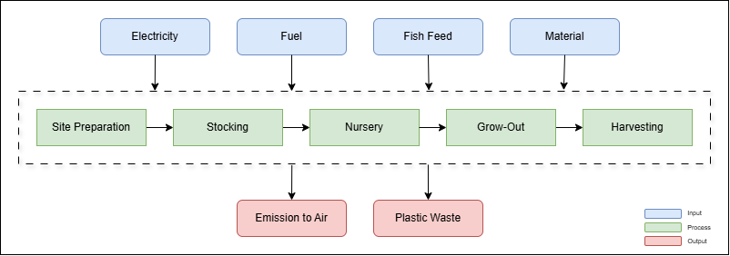
Figure 1. System Boundary

Any flow (material or energy) contributing less than 1% of the total mass or energy will be omitted unless known to have substantial environmental relevance. This cut-off rule is consistent with ISO 14044 guidance and commonly adopted in LCA work to balance completeness and practicality (Jouannais et al., 2023). The allocation is not required because the system produces a single main product without significant co-products or by-products.

System Description
The study was carried out in Tanjung Mas Village, Semarang City, Central Java, Indonesia as shown in Figure 2. This low-lying coastal sector of the Java Sea is strongly influenced by semidiurnal tides and the seasonal Asian-Australian monsoon system, which drives marked variability in rainfall, currents, and surface salinity across Indonesian waters (Adyasari et al., 2021). This study location in northern Semarang experiences tidal flooding and land subsidence, which influence fuel consumption and maintenance (Adnan et al., 2025).
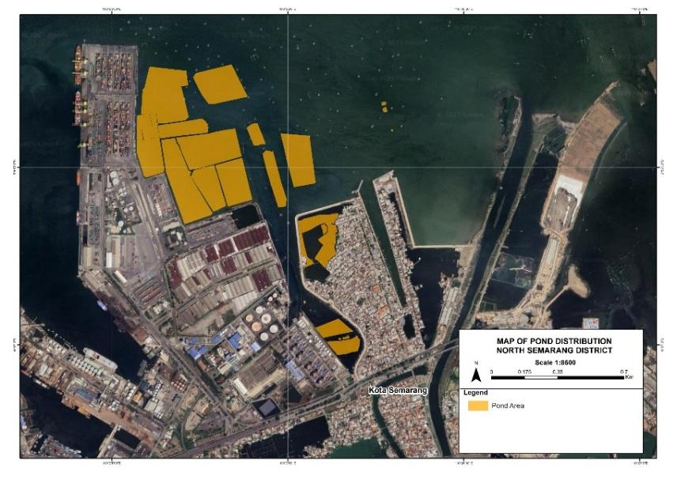
Figure 2. Map of Pond Area in North Semarang

Milkfish (Chanos chanos) in the coastal area are cultured in staked net cages constructed from bamboo stakes driven into the muddy seabed, forming rectangular enclosures that surround 1 ha of water surface at a depth of 3 m. Farmers deploy three-layer polyamide (nylon-6) nets, typically with a 0.5 cm mesh for nurseries and 1 cm mesh for grow-out, requiring approximately five 30 × 5 m rolls per module as shown in Figure 3. The open structure promotes water exchange and natural food availability. Nets are cleaned periodically to limit biofouling and are generally replaced every 2-3 production cycles. Production follows a 10-month cycle, from stocking hatchery fry (2-3 cm) to harvest (250-350 g), with daily routines of manual feeding, net inspection, and harvesting using small gasoline-powered boats.
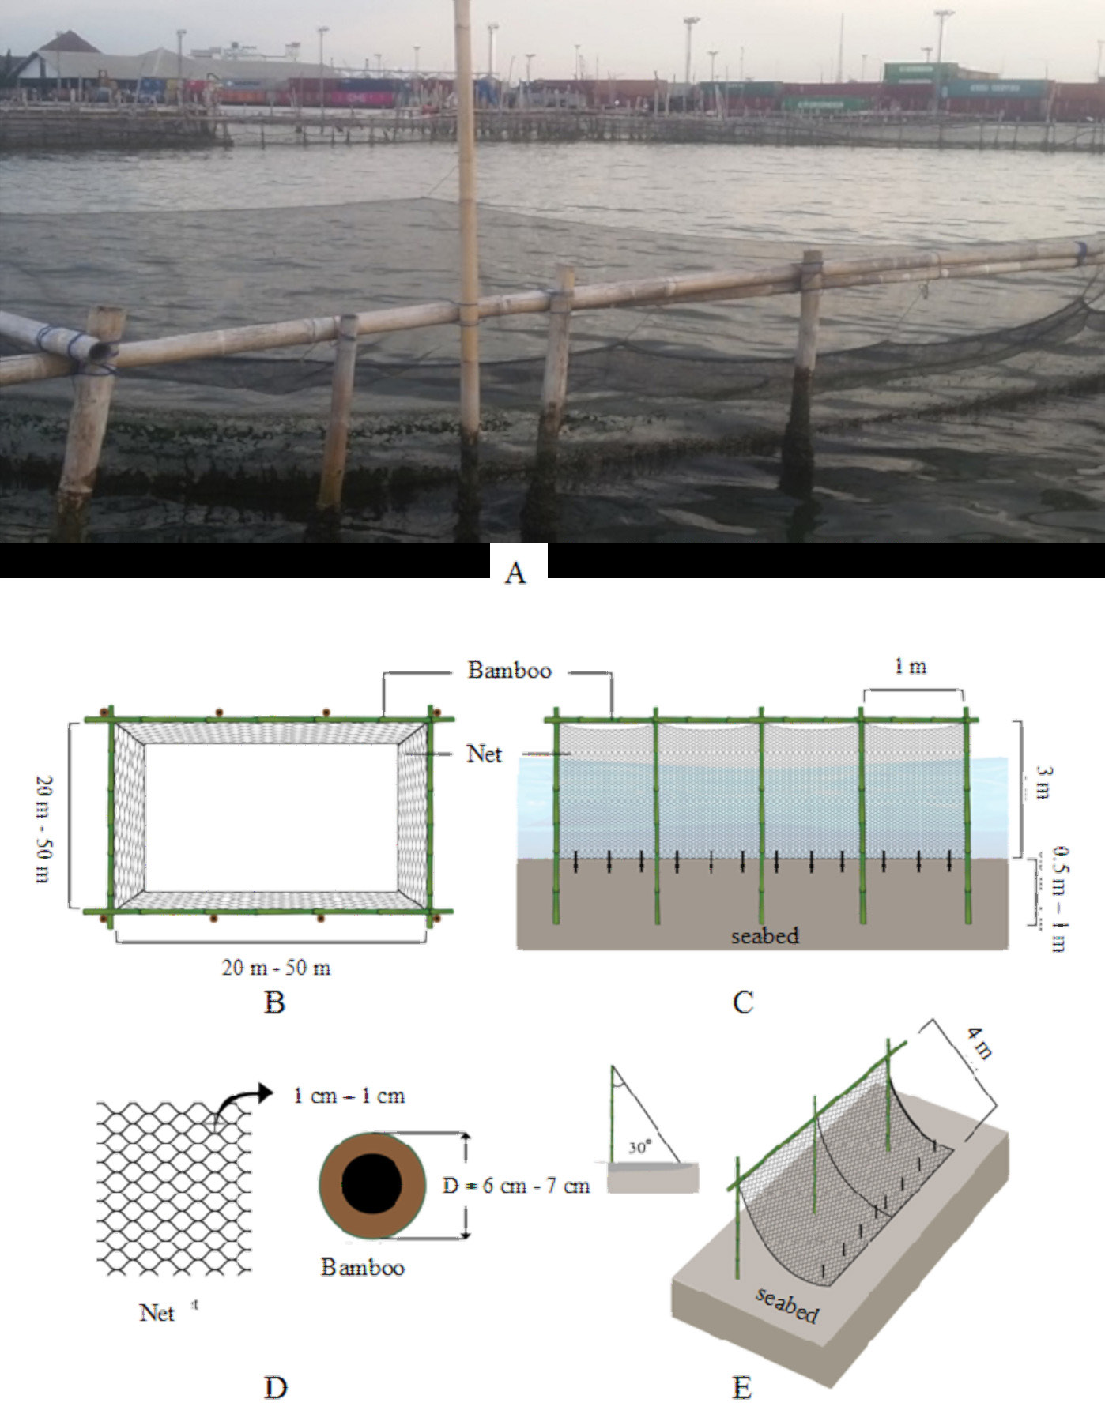
Figure 3. Detailed Design of Stick-net Cage Specification Used for Milkfish Cultivation:
A) existing stick-net cage; B) upper view of the net-cage; C) construction design; D) material specification; E) net position on the seabed

Life Cycle Inventory
Primary data were collected through field observations, interviews with farmers, and measurements of cage components. The data included net mass, replacement cycles, stake quantities, gasoline use, feed inputs, production duration, and survival rates. All flows were normalized to the functional unit. Foreground processes were linked to ecoinvent v3.8 datasets using SimaPro 9.5. Gasoline use was converted using standard Indonesian density (0.72-0.74 kg/L). Net and stake material flows were annualized per production cycle.

Life Cycle Impact Assessment
Environmental impacts were calculated using the ReCiPe 2016 Midpoint (H) method, chosen for its broad adoption in recent aquaculture studies and its ability to capture key mid-point indicators relevant to coastal fish farming. Five impact categories were assessed: global warming, fossil resource scarcity, terrestrial acidification, fine particulate matter formation, and ozone formation (terrestrial ecosystem).

RESULTS AND DISCUSSION
Life Cycle Inventory
The life cycle inventory phase is this study maps all input and output flows associated with milkfish (Chanos chanos) culture in a staked net cage system. Modeling was conducted under a gate-to-gate system boundary, which is limited to farmer-level activities from site preparation through harvesting. Five main process units are modeled based on field observations, namely: site preparation, stocking, nursery, grow-out, and harvesting. The compiled inventory is presented in the Table 1 below.
Table 1. Inventory Data
No | Process | Input/Output | Amount | Unit
1 | Site Preparation | Input
 |  | Bamboo | 18 | Ton
 |  | Outer net | 0.048 | Ton
 |  | Nylon | 0.001 | Ton
 |  | Rope | 0.044 | Ton
 |  | Inner net | 0.6 | Ton
 |  | Gasoline for boats | 96 | Liter
 |  | Gasoline for compressor | 21 | Liter
 |  | Output
 |  | CO₂ | 0.21859200 | Ton
 |  | CH₄ | 0.00001584 | Ton
 |  | N₂O | 0.00000190 | Ton
2 | Stocking | Input
 |  | Fingerlings | 0.175 | Ton
 |  | Plastic | 0.012 | Ton
 |  | Gasoline for boats | 9 | Liter
 |  | Oxygen | 0.096 | Ton
 |  | Output
 |  | CO₂ | 0.02049300 | Ton
 |  | CH₄ | 0.00000149 | Ton
 |  | N₂O | 0.00000018 | Ton
 |  | Plastic waste | 0.0117 | Ton
3 | Nursery | Input
 |  | Wheat flour waste | 2.7 | Ton
 |  | Gasoline for boats | 405 | Liter
 |  | Output
 |  | CO₂ | 0.92218500 | Ton
 |  | CH₄ | 0.00006683 | Ton
 |  | N₂O | 0.00000802 | Ton
 |  | Plastic waste | 0.0054 | Ton
4 | Grow-Out | Input
 |  | Bread waste | 2.7 | Ton
 |  | Wheat flour waste | 2.7 | Ton
 |  | Gasoline for boats | 810 | Liter
 |  | Output
 |  | CO₂ | 1.84437000 | Ton
 |  | CH₄ | 0.00013365 | Ton
 |  | N₂O | 0.00001604 | Ton
 |  | Plastic waste | 0.0108 | Ton
5 | Harvesting | Input
 |  | Seine net | 0.06 | Ton
 |  | Plastic bucket | 0.006 | Ton
 |  | Fish crate | 0.008 | Ton
 |  | Fish box | 0.664 | Ton
 |  | Ice cubes | 0.415 | Ton
 |  | Gasoline for boats | 120 | Liter
 |  | Output
 |  | CO₂ | 0.27324000 | Ton
 |  | CH₄ | 0.00001980 | Ton
 |  | N₂O | 0.00000238 | Ton
 |  | Harvested milkfish | 40 | Ton

The validity and consistency of the LCI were verified by normalizing all flows to the functional unit of 1 ton of live fish, harmonizing units, and converting daily records to cycle totals. Mass and energy balances were evaluated, and material inputs were prorated over their useful lifetimes to prevent double-counting. Inventory completeness was examined using cut-off thresholds, and the suitability of dataset mapping (e.g., fuel type, net material) was reviewed. Accordingly, the LCI satisfies criteria of completeness, consistency, and representativeness and is fit for use in the subsequent LCIA.

Characterization
The characterization phase was conducted to calculate the potential environmental impact of each process unit in the staked net cage cultivation system. This analysis used the ReCiPe 2016 Midpoint (H) method for five categories: Global Warming, Fine Particulate Matter Formation, Ozone Formation (terrestrial ecosystems), Terrestrial Acidification, and Fossil Resource Scarcity. The characterization results indicate the magnitude of the impact for each category, but because each category has different units, the results between categories are not directly compared. Instead, the discussion focused on identifying which process steps contribute most to the total environmental burden and explaining the scientific causal factors. This approach is in accordance with ISO 14044 interpretation guidelines and LCA practices in small-to-medium aquaculture.
Table 2. Characterization Result
Impact Category | Unit | Total | Site Preparation | Stocking | Nursery | Grow-Out | Harvesting
Global warming | kg CO2 eq | 436.24813 | 278.6478 | 1.4496 | 31.0196 | 62.0132 | 63.1177
Fine particulate matter formation | kg PM2.5 eq | 0.45061352 | 0.3697 | 0.0010 | 0.0093 | 0.0186 | 0.0518
Ozone formation, Terrestrial ecosystems | kg NOx eq | 0.83767391 | 0.6314 | 0.0024 | 0.0253 | 0.0506 | 0.1278
Terrestrial acidification | kg SO2 eq | 0.96823358 | 0.7422 | 0.0025 | 0.0276 | 0.0551 | 0.1406
Fossil resource scarcity | kg oil eq | 137.32002 | 74.9367 | 0.7167 | 9.0892 | 18.1482 | 34.4290

Based on Table 2, site preparation is the largest contributor to all categories assessed. In global warming, this stage reaches 278.65 kg CO₂-eq or about 63.9% of the total 436.25 kg CO₂-eq. Similar dominance is seen in Fine particulate matter formation, which is 0.3697 kg PM1.5-eq or around 82% of the total 0.4506 kg PM2.5-eq, Ozone formation - terrestrial ecosystems, which is 0.6314 kg NOx-eq or around 75% of 0.8377 kg NOx-eq, Terrestrial acidification which is 0.7422 kg SO₂-eq or around 76.7% of 0.9682 kg SO₂-eq, and Fossil resource scarcity, which is 74.94 kg oil-eq or around 54.6% of 137.32 kg oil-eq. The contribution of stocking is marginal (<5% in all impact categories), while in the nursery process, the environmental impact burden begins to increase, especially in GWP of 31.02 kg CO₂-eq, along with the start of feed use and routine operations.
In the next operational phase, grow-out and harvesting provide similar contributions to GWP, namely 62.01 kg CO₂-eq and 63.12 kg CO₂-eq, and increase the impact burden on Terrestrial acidification, namely 0.0551 kg SO₂-eq and 0.1406 kg SO₂-eq, and Ozone formation (terrestrial), namely 0.0506 kg NOx-eq and 0.1278 kg NOx-eq. Thus, the contribution per process to the impact, from the largest to the smallest, is site preparation, followed by grow-out and harvesting which are relatively equivalent, then nursery, and the lowest is stocking.

Hotspot Analysis
Based on the characterization results using the ReCiPe 2016 Midpoint (H) method, the total environmental impact of the Staked Net Cage system is dominated by two main sources, namely nylon-6 net material and air emissions from fossil fuel combustion. This Figure 4 below is a graphical image of the characterization results.
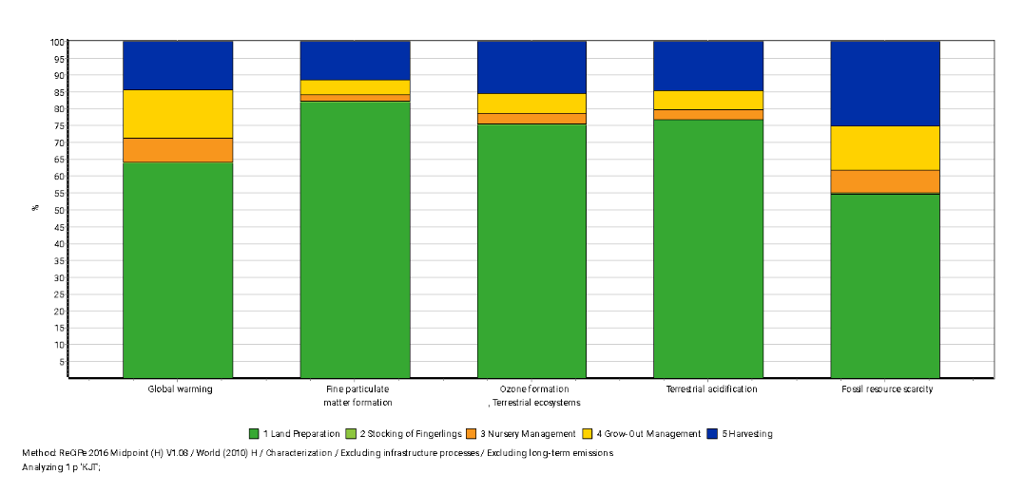
Figure 4. Characterization Graph

Nylon-6 material has high energy and carbon intensity because it is produced from petrochemical materials that require high-temperature polymerization and extrusion processes. This makes net and rope components a significant contributor to the resource depletion and acidification categories through their production energy footprint. Then the combustion of gasoline in boat operations appears as a major driver of global warming, fine particulate matter formation, ozone formation (terrestrial), and terrestrial acidification through CO2, CH4, N2O emissions. This fuel-based burden is mainly accumulated in grow-out (patrol, feeding, net inspection) and harvesting (harvest mobilization).
These results are consistent with several studies, including Thomas et al. (2024) study on the LCA of kelp farming, which showed that farming equipment/infrastructure and boat operations were often the primary determinants of several impact categories. Furthermore, De Luca Peña et al. (2024) study on offshore multi-use systems found that the largest contribution came from the material supply chain for manufacturing farm components, followed by operational activities.

Normalization
The normalization stage aims to assess the relative contribution of each impact category to the total environmental burden of the milkfish farming system at staked net cage. This process is carried out using the ReCiPe 2016 World (H) method, where the characterization results are calibrated against the global average value so that each category is expressed in relative units (points). This stage allows comparisons between impact categories to identify the dominant impacts that have the most influence overall. The analysis is conducted on five main categories: Global Warming Potential (GWP), Fossil Resource Scarcity (FRS), Ozone Formation (OF), Terrestrial Acidification (TA), and Fine Particulate Matter Formation (PMF).

Table 3. Normalization Result
Impact Category | Total | Site Preparation | Stocking | Nursery | Grow-Out | Harvesting
Global warming | 5,45E-02 | 3,48E-02 | 1,81E-04 | 3,88E-03 | 7,75E-03 | 7,89E-03
Fine particulate matter formation | 1,76E-02 | 1,45E-02 | 4,20E-05 | 3,65E-04 | 7,29E-04 | 2,03E-03
Ozone formation, Terrestrial ecosystems | 4,72E-02 | 3,55E-02 | 1,37E-04 | 1,43E-03 | 2,85E-03 | 7,20E-03
Terrestrial acidification | 2,36E-02 | 1,81E-02 | 6,31E-05 | 6,74E-04 | 1,35E-03 | 3,43E-03
Fossil resource scarcity | 1,40E-01 | 7,64E-02 | 7,31E-04 | 9,27E-03 | 1,85E-02 | 3,51E-02

Based on Table 3, Normalization places Fossil resource scarcity as the most dominant category (0.140 pt), followed by Global warming (0.0545 pt), Ozone formation in terrestrial ecosystems (0.0472 pt), Terrestrial acidification (0.0236 pt), and Fine particulate matter formation (0.0176 pt). Cross-category comparisons show that site preparation remains the largest contributor after normalization, which is around 55% of the total points of Fossil resource scarcity (0.0764/0.140), 64% of Global warming (0.0348/0.545), 75% of Ozone formation, terrestrial ecosystems (0.0355/0.0472), 77% of Terrestrial acidification (0.0181/0.0236), and 82% of Fine particulate matter formation (0.0145/0.0176). This dominance is consistent with the material and energy intensity of the infrastructure installation and initial mobilization phases.
The operational phase’s contribution is next in line. Grow-out contributes approximately 14% of the global warming score (0.00775/0.0545) and 13% of fossil resource scarcity (0.0185/0.140), followed by smaller contributions to ozone formation (6%), acidification (6%), and PM formation (4%). This reflects the influence of gasoline combustion for patrolling, feeding, and net inspection. Nursery falls below this, while stocking is generally marginal (<1% in almost all categories), except for approximately 5% in FRS related to gasoline use for seed transportation.
Overall, the normalization results place Fossil Resource Scarcity as the most dominant category, followed by Global Warming, Ozone Formation (terrestrial ecosystems), Terrestrial Acidification, and finally Fine Particulate Matter Formation as can be seen in the Figure 5, confirming that dependence on fossil resources and combustion emissions are the main drivers of the environmental burden on the system.
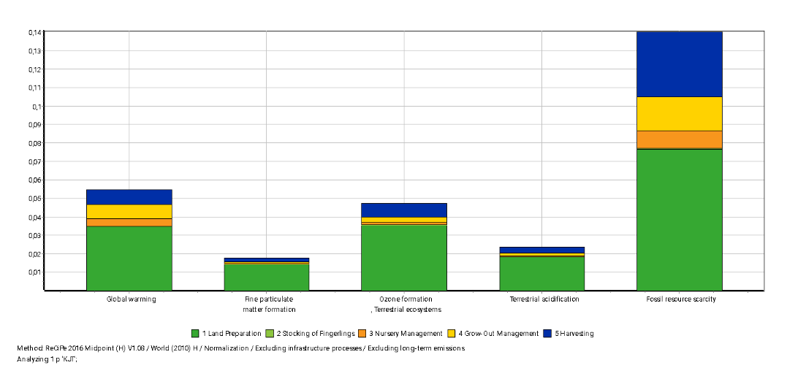
Figure 5. Normalization Graph

Based on the study's findings, mitigation focuses on two main areas of concern: nylon-6-based net materials and gasoline combustion in boat operations. For the first hotspot, actions that can be taken include extending the net’s lifespan through scheduled maintenance and cleaning, as well as repair/patching programs, along with evaluating alternatives made from recycled materials with similar functional performance. Previous LCA research evidence indicates that increasing lifespan and recyclability reduces the environmental footprint of aquaculture infrastructure components (Pasciucco et al., 2025). For the second hotspot, fuel efficiency can be achieved through route optimization, scheduled engine maintenance to reduce fuel consumption, and the use of low-sulfur fuel.
The interpretation of results is constrained by the use of proxy datasets for bamboo-based materials and certain feed components, as region-specific life-cycle inventories remain limited for tropical aquaculture systems. The analysis was conducted under a gate-to-gate boundary, which does not account for hatchery inputs and downstream distribution and may influence the magnitude of total environmental burdens.
Further refinement of the assessment may be achieved by incorporating cradle-to-grave system boundaries and improving the availability of localized datasets for key materials and feed ingredients. A broader evaluation of alternative net materials and operational configurations could also enhance understanding of potential environmental improvements in coastal net cage aquaculture.

CONCLUSIONS
This study assessed the environmental performance of milkfish production in staked net cages in coastal Semarang using LCA. The results show that infrastructure materials, particularly nylon-6 nets and bamboo stakes, contributed the largest share of impacts across all categories. Fuel use during daily operations also played a significant role, particularly in terms of global warming and air pollutant-related impacts. Among the evaluated impact categories, fossil resource scarcity and global waming potential exhibited the highest relative contributions after normalization. These findings establish the dominant sources of environmental pressure within the system and provide a clear summary of the ovreall impact profile of staked net cage milkfish aquaculture.

ACKNOWLEDGEMENTS
The author would like to express gratitude to the Directorate of Research and Community Service, Ministry of Higher Education, Science, and Technology (DPPM Kemendiktisaintek), for funding support for this research based on Master Contract Number: 089/C3/DT.05.00/PL/2025. Gratitude is also extended to the Research and Community Service Institute of Universitas Negeri Semarang for facilitating the implementation of this programme through Subcontract Number: 47.2.6/UN37/PPK.11/2025. The support from the Milkfish Staked Net Cage Aquaculture Center in Tanjung Mas Village, Semarang City, along with all local fish farmers and community members who actively participated, was instrumental in the success of this programme.

REFERENCES
- Adnan, B., Endriani Arhatin, R., Lumban-Gaol, J., & Budi Susilo, S. (2025). Spatial distribution of tidal flooding in the coastal areas of Demak Regency, Central Java. BIO Web of Conferences, 168. https://doi.org/10.1051/bioconf/202516805012
- Adyasari, D., Pratama, M. A., Teguh, N. A., Sabdaningsih, A., Kusumaningtyas, M. A., & Dimova, N. (2021). Anthropogenic impact on Indonesian coastal water and ecosystems: Current status and future opportunities. In Marine Pollution Bulletin (Vol. 171). Elsevier Ltd. https://doi.org/10.1016/j.marpolbul.2021.112689
- Alimorin, J. M. L. (2025). Sustainable Aquaculture Practices for Milkfish (Chanos chanos): An Integrated Analysis of Environmental, Economic, and Policy Dimensions in Asia. International Journal of Research and Review, 12(7), 468–490. https://doi.org/10.52403/IJRR.20250749
- Bohnes, F. A., Hauschild, M. Z., Schlundt, J., & Laurent, A. (2019). Life cycle assessments of aquaculture systems: a critical review of reported findings with recommendations for policy and system development. Reviews in Aquaculture, 11(4), 1061–1079. https://doi.org/10.1111/RAQ.12280
- Chairat, S., Regmi, S., Cheng, H. W., Vongmahadlek, P., & Gheewala, S. H. (2025). Life cycle assessment of Tilapia production via conventional aquaculture and aquaponic systems. Aquaculture, 608. https://doi.org/10.1016/j.aquaculture.2025.742760
- Dalimunthe, S. A., Santosa, B. H., Surtiari, G. A. K., Reksa, A. F. A., Ardiyanto, R., Putiamini, S., Agustan, A., Ito, T., & Purwana, R. (2025). Subsiding Cities: A Case Study of Governance and Environmental Drivers in Semarang, Indonesia. Urban Science 2025, Vol. 9, Page 266, 9(7), 266. https://doi.org/10.3390/URBANSCI9070266
- De Luca Peña, L. V., Bas, B., Dewulf, J., van den Burg, S. W. K., & Taelman, S. E. (2024). Environmental Life Cycle Assessment of multi-use of marine space: A comparative analysis of offshore wind energy and mussel farming in the Belgian Continental Shelf with terrestrial alternatives. Journal of Cleaner Production, 470, 143271. https://doi.org/10.1016/J.JCLEPRO.2024.143271
- Dullah, H., Malek, M. A., & Hanafiah, M. M. (2020). Life cycle assessment of Nile Tilapia (oreochromis niloticus) farming in Kenyir Lake, Terengganu. Sustainability (Switzerland), 12(6). https://doi.org/10.3390/su12062268
- Ghamkhar, R., Boxman, S. E., Main, K. L., Zhang, Q., Trotz, M. A., & Hicks, A. (2021). Life cycle assessment of aquaculture systems: Does burden shifting occur with an increase in production intensity? Aquacultural Engineering, 92, 102130. https://doi.org/10.1016/J.AQUAENG.2020.102130
- Henriksson, P. J. G., Guinée, J. B., Kleijn, R., & De Snoo, G. R. (2012). Life cycle assessment of aquaculture systems-A review of methodologies. International Journal of Life Cycle Assessment, 17(3), 304–313. https://doi.org/10.1007/S11367-011-0369-4
- Jouannais, P., Gibertoni, P. P., Bartoli, M., & Pizzol, M. (2023). LCA to evaluate the environmental opportunity cost of biological performances in finfish farming. International Journal of Life Cycle Assessment, 28(10), 1286–1301. https://doi.org/10.1007/s11367-023-02211-8
- Okechi, J. K., Peoples, N., Nyamweya, C. S., Orina, P. S., Cooperman, M. S., & Kaufman, L. (2025). Effects of Nile tilapia (Oreochromis niloticus) cage aquaculture on water quality in the world’s largest tropical lake. Journal of Great Lakes Research, 51(3), 102576. https://doi.org/10.1016/J.JGLR.2025.102576
- Pagnotta, L. (2025). Sustainable Netting Materials for Marine and Agricultural Applications: A Perspective on Polymeric and Composite Developments. Polymers 2025, Vol. 17, Page 1454, 17(11), 1454. https://doi.org/10.3390/POLYM17111454
- Pasciucco, F., Rossi, D., Maccaferri, E., Pecorini, I., Giorgini, L., & Seggiani, M. (2025). Recycling polyamide 6 fishing nets and carbon fibers for the development of novel sustainable composites: Properties and LCA process analysis. Journal of Cleaner Production, 486. https://doi.org/10.1016/J.JCLEPRO.2024.144634
- Pianjing, P., & Wites, J. (2021). Life Cycle Analysis of Milkfish Fingerlings Production in Thailand. International Journal of Environmental Science and Development, 12(11), 332–338. https://doi.org/10.18178/IJESD.2021.12.11.1358
- Romadhona, S., & Arifandi, J. A. (2020). FACTORS OF COASTAL COMMUNITIES OF SEMARANG RELUCTANCE TO MOVE FROM THE COASTAL AREA. GeoEco, 6(2), 133–147. https://doi.org/10.20961/GE.V6I2.41150
- Rossi, L., Zoli, M., Capoccioni, F., Pulcini, D., Martini, A., & Bacenetti, J. (2024). Insights into different marine aquaculture infrastructures from a life cycle perspective. Aquacultural Engineering, 107. https://doi.org/10.1016/j.aquaeng.2024.102462
- Supartono, W. (Wahyu), Utami, W. S. (Widha), & Nugroho, D. A. (Darmawan). (2015). Proposed Implementation of Life Cycle Assessment (ISO 14040) on Spiced Boneless Milkfish (Chanos Chanos) Production. KnE Life Sciences, 3(3), 17–20. https://doi.org/10.18502/KLS.V3I3.403
- Tahiluddin, A. B., Bornales, J. C., Limbaro, G. R. A., Paudac, M. A. T. U., Amarille, R. K., Sirad, N. R., Kabirun, M. C., Ujing, R. A., Gonzaga-Torino, F. M., Sabdani, M. H., Bacla-An, R. E., Hairal, M. A. J. S., Magcanta-Mortos, M. L. M., & Esguerra, J. P. (2025). Environmental Impacts of Aquaculture in the Philippines. Israeli Journal of Aquaculture - Bamidgeh, 77(2), 51–81. https://doi.org/10.46989/001C.133778
- The State of World Fisheries and Aquaculture 2024. (2024). In The State of World Fisheries and Aquaculture 2024. FAO. https://doi.org/10.4060/cd0683en
- Thomas, J. B. E., Ahlgren, E., Hornborg, S., & Ziegler, F. (2024). Life cycle environmental impacts of kelp aquaculture through harmonized recalculation of inventory data. Journal of Cleaner Production, 450. https://doi.org/10.1016/J.JCLEPRO.2024.141987
- Zoli, M., Rossi, L., Fronte, B., Aubin, J., Jaeger, C., Wilfart, A., Bibbiani, C., & Bacenetti, J. (2024). Environmental impact of different Mediterranean technological systems for European sea bass (Dicentrarchus labrax) and Gilthead sea bream (Sparus aurata) farming. Aquacultural Engineering, 107, 102457. https://doi.org/10.1016/J.AQUAENG.2024.102457

